Department of Rehabilitation

Greater Los Angeles District (440-00)
(213) 736-3904 (Voice)
(213) 736-3960 (TTY)
3333 Wilshire Blvd. , Suite 200
Los Angeles, CA 90010-4101
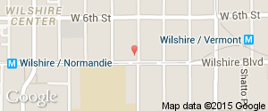
(More details about the Greater Los Angeles District)
(Los Angeles County Offices)
(Greater Los Angeles District Interactive Google Map)

City of Commerce Branch (440-05)
(323) 720-4073 (Voice)
(323) 721-5142 (TTY)
5400 E. Olympic Boulevard , Suite 200
City of Commerce, CA 90022-5147
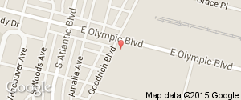
(More details about the City of Commerce Branch)
(Los Angeles County Offices)
(City of Commerce Branch Interactive Google Map)

Culver City Branch (440-03)
(310) 559-6140 (Voice)
6125 Washington Blvd. , Suite 200
Culver City, CA 90232-7458
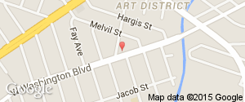
(More details about the Culver City Branch)
(Los Angeles County Offices)
(Culver City Branch Interactive Google Map)

East Los Angeles Branch (440-06)
(323) 223-2315 (Voice)
(323) 224-6068 (TTY)
1640 Marengo Street , Suite 500
Los Angeles, CA 90033-1036
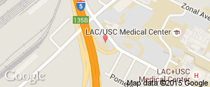
(More details about the East Los Angeles Branch)
(Los Angeles County Offices)
(East Los Angeles Branch Interactive Google Map)

Norwalk Branch (440-07)
(562) 864-8521 (Voice)
12501 East Imperial Hwy. , Suite 140
Norwalk, CA 90650-8314
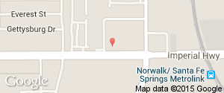
(More details about the Norwalk Branch)
(Los Angeles County Offices)
(Norwalk Branch Interactive Google Map)

Westchester Branch (440-04)
(323) 298-2500 (Voice)
(323) 298-2521 (TTY)
5120 Goldleaf Circle , Suite 360
Los Angeles, CA 90056
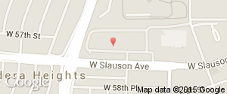
(More details about the Westchester Branch)
(Los Angeles County Offices)
(Westchester Branch Interactive Google Map)

